**LAB#5**

**Object:** Write a program to print two strings on separate lines.

dosseg

.model small

.stack 100h

.data

string_1 db ‘ASSALAM-O-ALAIKUM $’

string_2 db ‘PAKISTAN ZINDABAD $’

.code

main proc

mov ax,@data

mov ds,ax

lea dx,string_1

mov ah,9

int 21h

mov ah,2

mov dl,0dh

int 21h

mov dl,0ah

int 21h

lea dx,string_2

mov ah,9

int 21h

mov ah,4ch

int 21h

main endp

end main

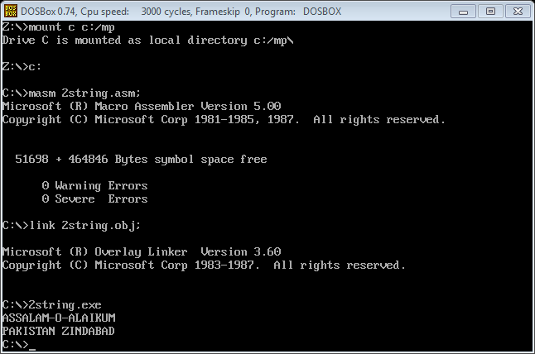

**Object:** write a program to print string using offset command.

dosseg

.model small

.stack 100h

.data

msg db'Hello World! How are you? $'

.code

main proc

mov ax,@data

mov ds,ax

mov ah,9

mov dx,offset msg

int 21h

mov ah,4ch

int 21h

main endp

end main

